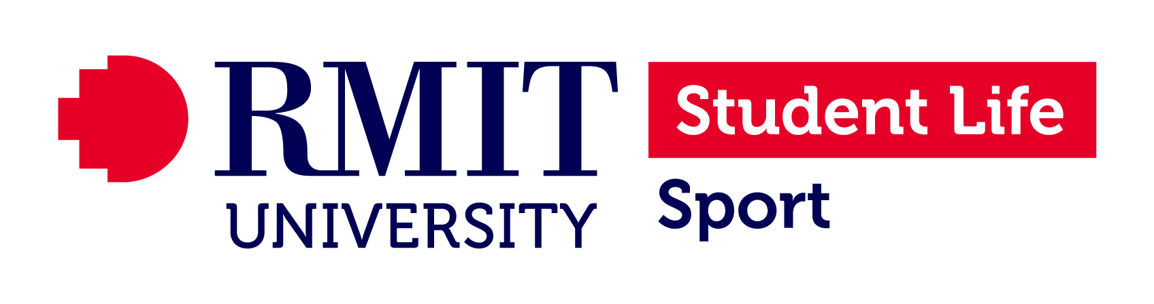
Appendix 11 – RMIT Safe Work Method Statement

DETAILS
Name(s): (of assessors; include name and position of employee, management rep, health and safety rep and/or contractor) |  |  |  |  |  | Date: / /
1. |  | 3. |  | 5.
2. |  | 4. |  | 6.

Description of activity:

Location of task:

Permit to work requirement? (e.g., confined spaces, hot works, working at heights etc…) |  | Yes |  | No | Approved by: (name and position)
(If yes add type of permits required to Tasks Column)
Tasks  List the tasks required to perform the activity in the sequence they are carried out. | Hazards  Against each task list the hazards that could cause injury when the task is performed. | Risk Control Measures  List the control measures required to eliminate or minimize the risk of injury arising from the identified hazard. | Responsibility  Write the name of the person responsible (supervisor or above) to implement the control measure identified.

SGNATURES (where applicable)

Manager: |  |  |  | Employee:
HSR: |  |  |  | Contractor/s:
PERSONNEL INDUCTED: (Signatures of employees trained in the work covered by this SWMS. Add pages as necessary) |  |  |  |  | EMPLOYER: (Name of Company)
PRINT NAME |  | SIGNED |  |  | EMPLOYER |  | DATE
COORDINATED BY:
NAME: (Please print)
SIGNED: |  |  | DATE: / /

